**ASSIGNMENT 2 FRONT SHEET**

|  |  |  |  |
| --- | --- | --- | --- |
| **Qualification** | **BTEC Level 5 HND Diploma in Computing** | | |
| **Unit number and title** | Unit 16: Cloud Computing | | |
| **Submission date** |  | **Date Received 1st submission** |  |
| **Re-submission Date** |  | **Date Received 2nd submission** |  |
| **Student Name** | Nguyen Gia Bach | **Student ID** | Gch220163 |
| **Class** | GCH1102 | **Assessor name** | Nguyen Dinh Tran Long |
| **Student declaration**  I certify that the assignment submission is entirely my own work and I fully understand the consequences of plagiarism. I understand that making a false declaration is a form of malpractice. | | | |
|  |  | **Student’s signature** |  |

**Grading grid**

|  |  |  |  |  |  |  |  |
| --- | --- | --- | --- | --- | --- | --- | --- |
| P5 | P6 | P7 | P8 | M3 | M4 | D2 | D3 |
|  |  |  |  |  |  |  |  |

|  |  |  |
| --- | --- | --- |
| **❒ Summative Feedback: ❒ Resubmission Feedback:** | | |
| **Grade:** | **Assessor Signature:** | **Date:** |
| **Internal Verifier’s Comments:** | | |
| **Signature & Date:** | | |

Table of Contents

I. Introduction: 4

II. Design: 4

1. Use case diagram: 4

2. Website screen shoot: 5

a) Homepage/Index page: 5

b) About page: 5

c) Shop page: 6

d) Contact page: 6

e) Category drone1 page: 7

f) Category drone2 page: 7

g) Add page: 8

h) List page: 8

i) Edit page: 9

j) Confirm: 9

# Introduction:

In the previous paper, we discussed some key concepts of cloud computing. This essay will illustrate how to create a web application in the cloud using the approach offered in the previous report. The web application will be built with NodeJS and will use MongoDB as its database. The web will be deploy on internet with Render.

# Design:

## Use case diagram:

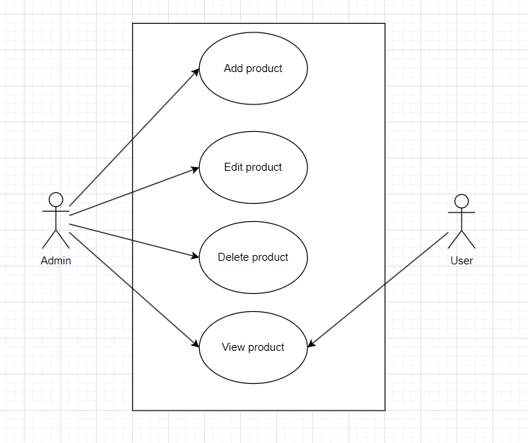

Figure 1: Use case diagram.

* Web application have several functions:
* Add/Update/Delete/View product.

## Website screen shoot:

### Homepage/Index page:

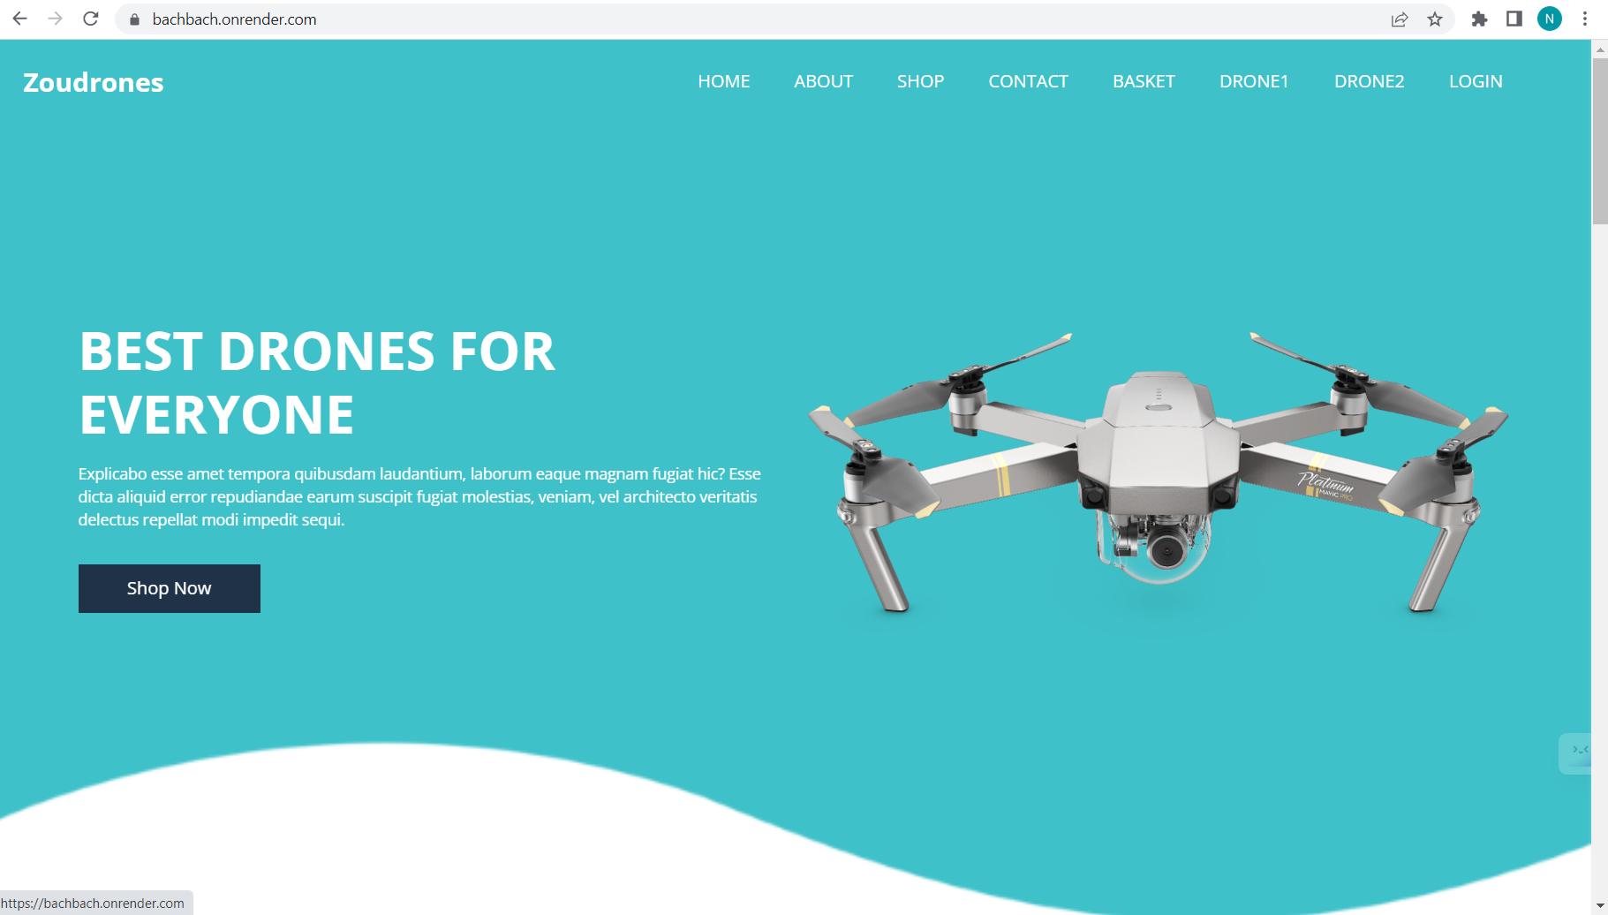

Figure 2: Home page

* This is the home page of the web site, user can scroll down to see more information.

### About page:

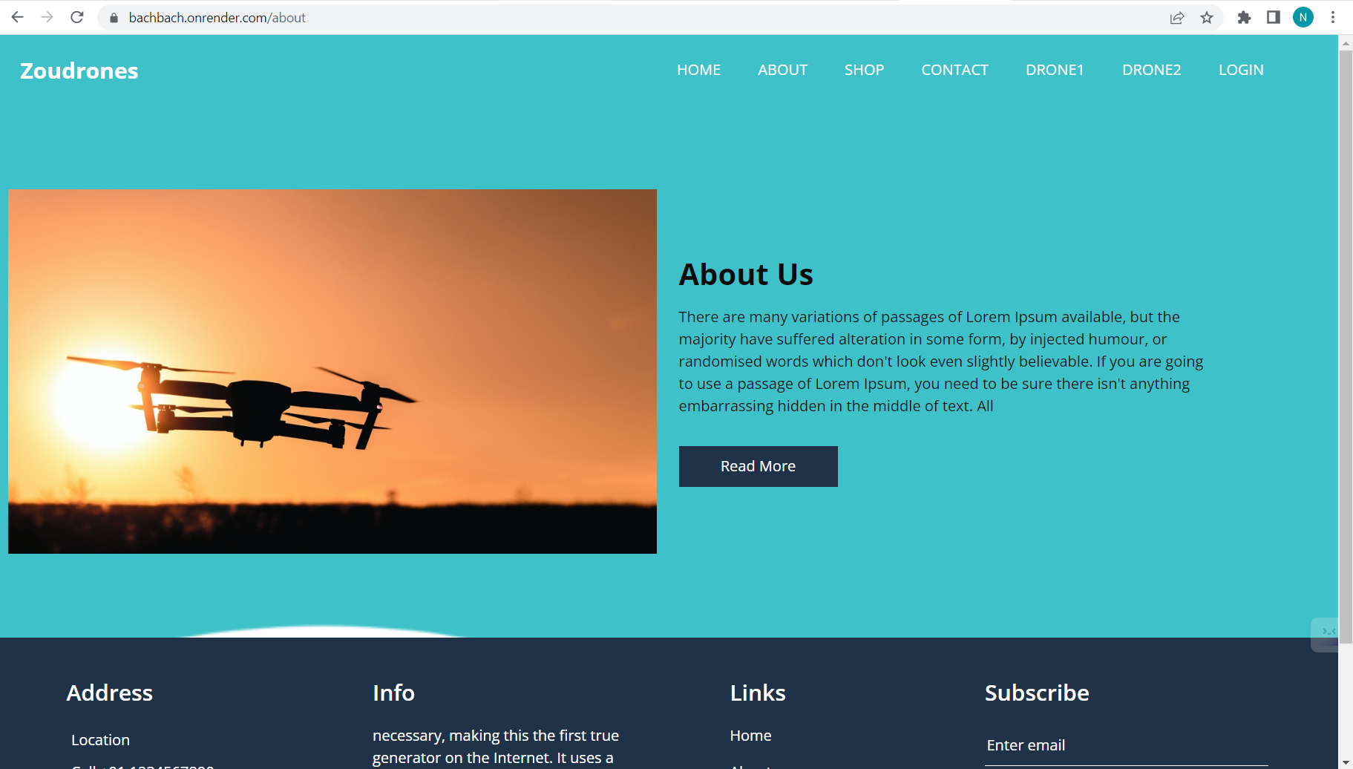

Figure 3: About page.

* This is the page of the shop information and introduction.

### Shop page:

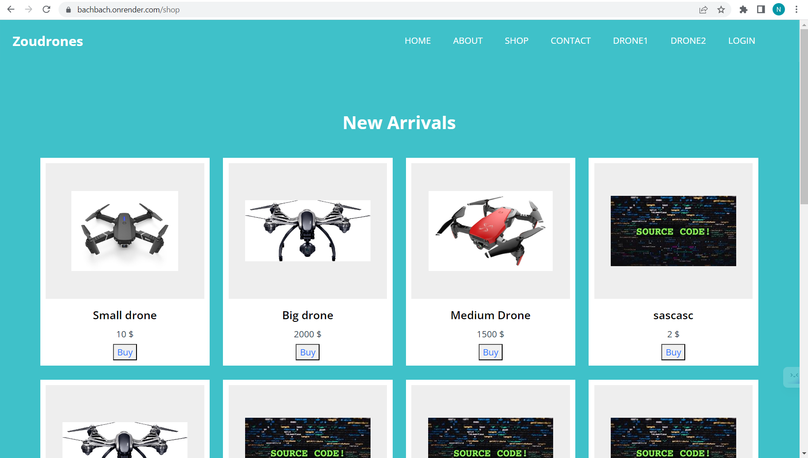

Figure 4: Shop page.

* This is the page that show all products.

### Contact page:

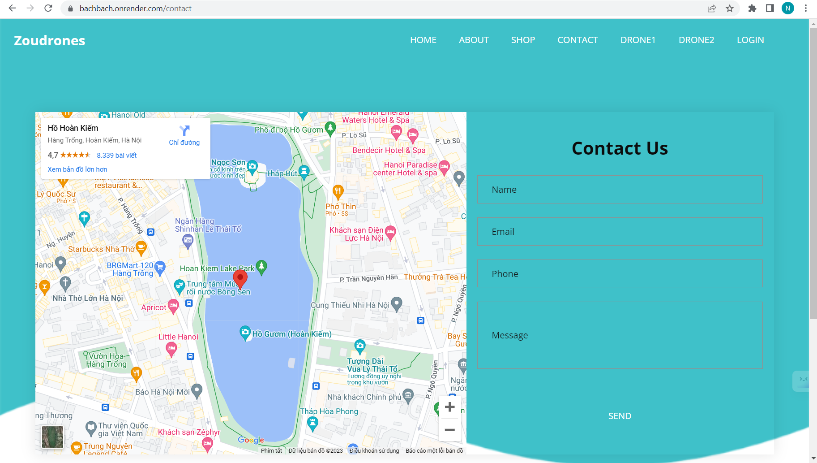

Figure 5: Contact page.

* This is the page that allow customer to contact the shop and see the shop location.

### Category drone1 page:

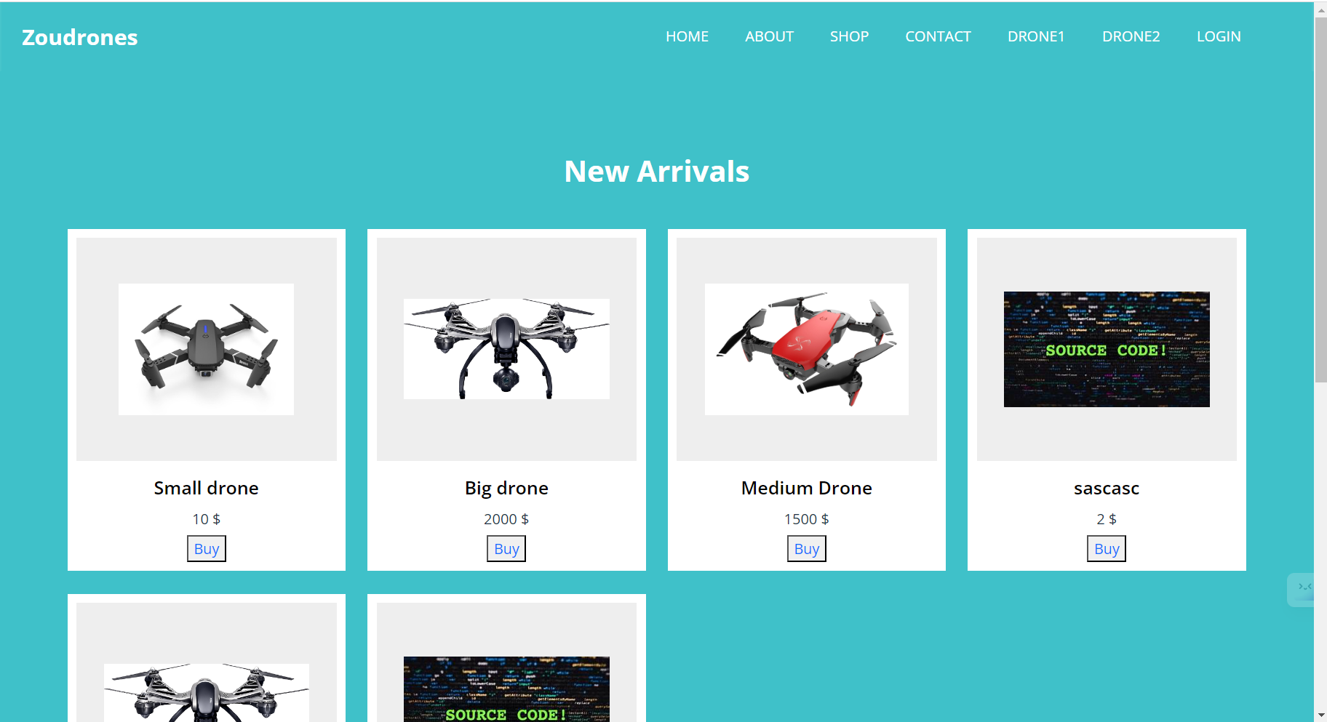

Figure 6: Category drone1 page.

* This page only show drones that are in category 1.

### Category drone2 page:

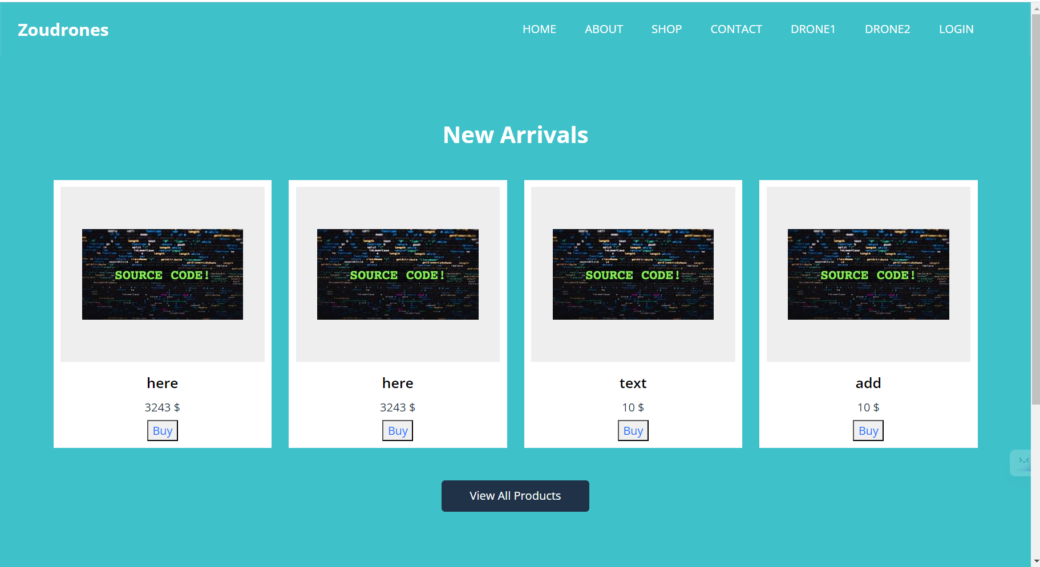

Figure 7: Category drone2 page.

* This page only show drones that are in category 2.

### Add page:

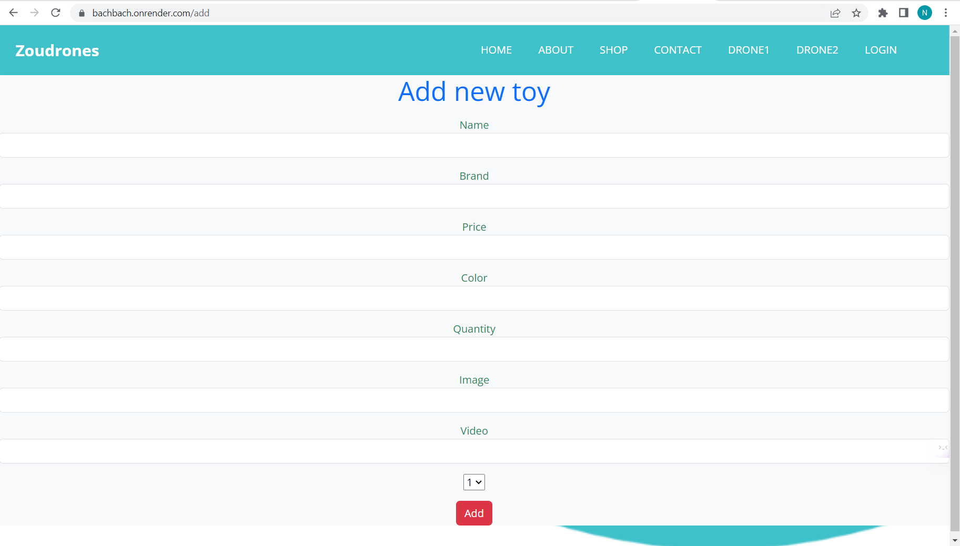

Figure 8: Add page.

* This is the page for admin to add more products. Admin can add product and choose products category in the drop down box at the bottom.

### List page:

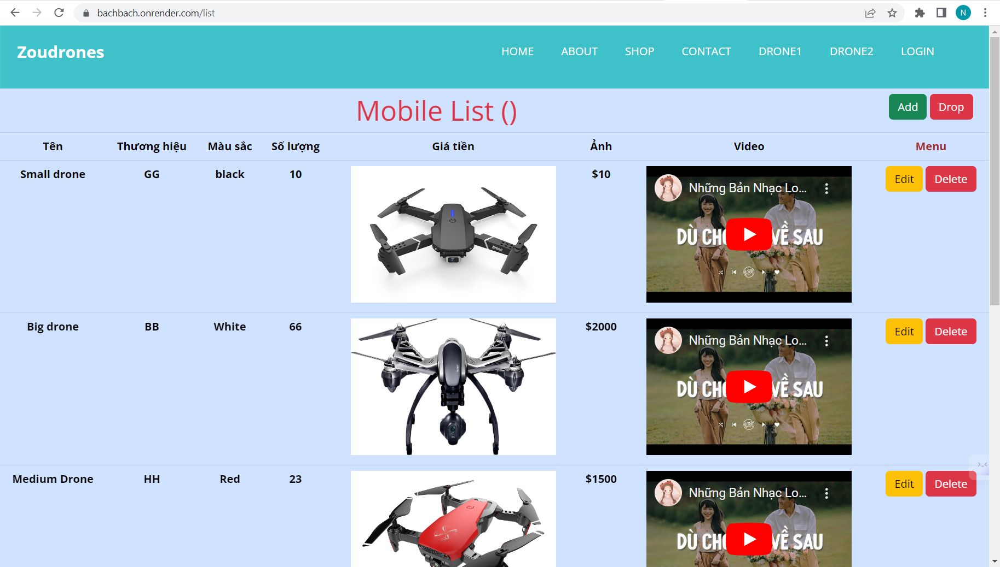

Figure 9: List page.

* This page allow admin to edit and delete product. The add page will appear if the green “add” button at the right top is clicked. Admin can also delete all products by click on the “drop” button.

### Edit page:

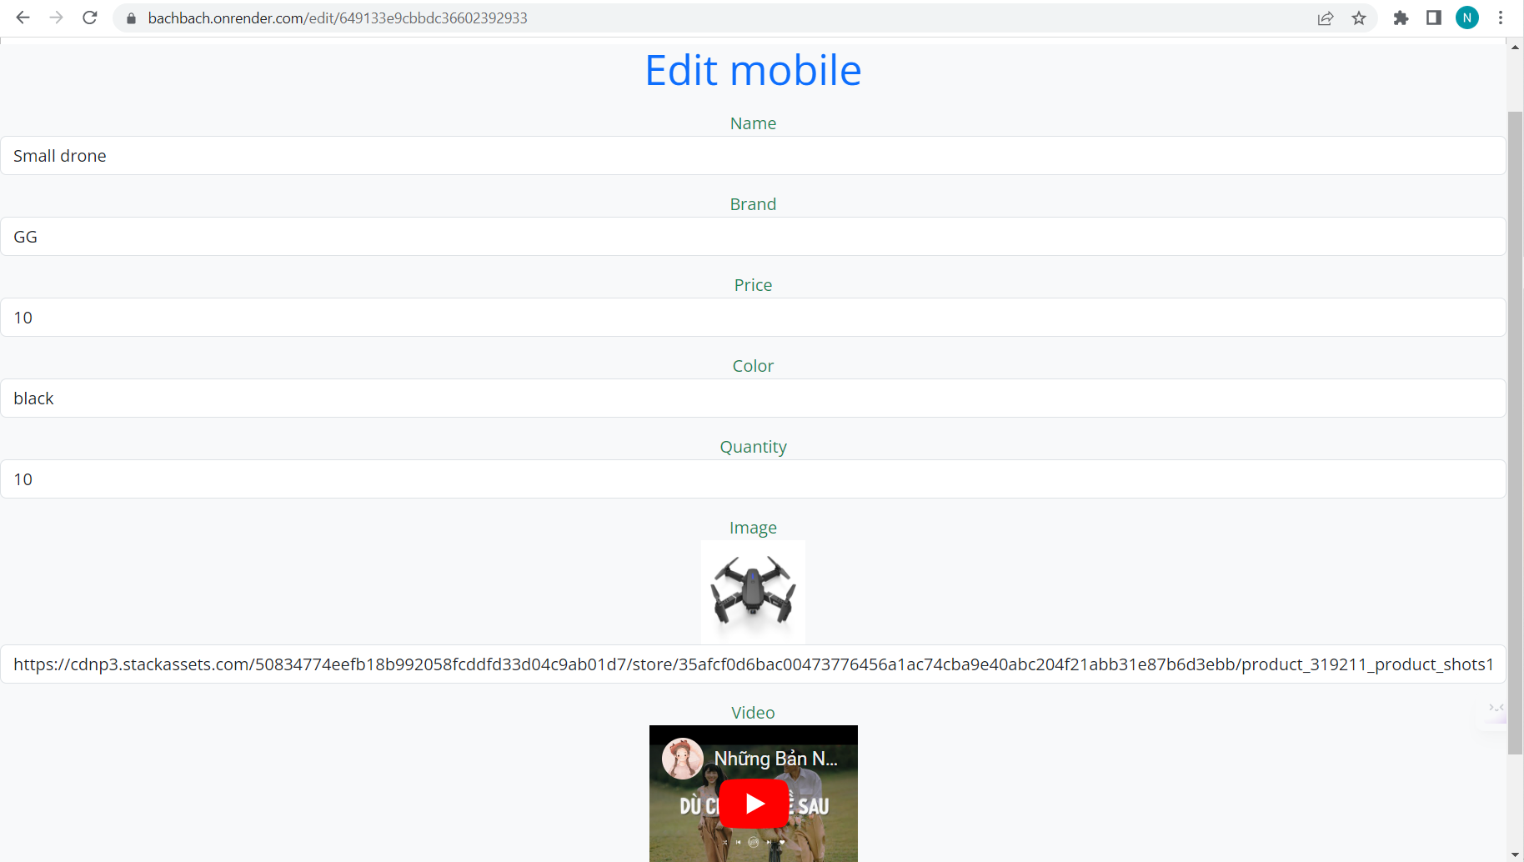

Figure 10: Edit page.

* This page will appear when Edit button is pressed. Admin can edit all product information here.

### Confirm:

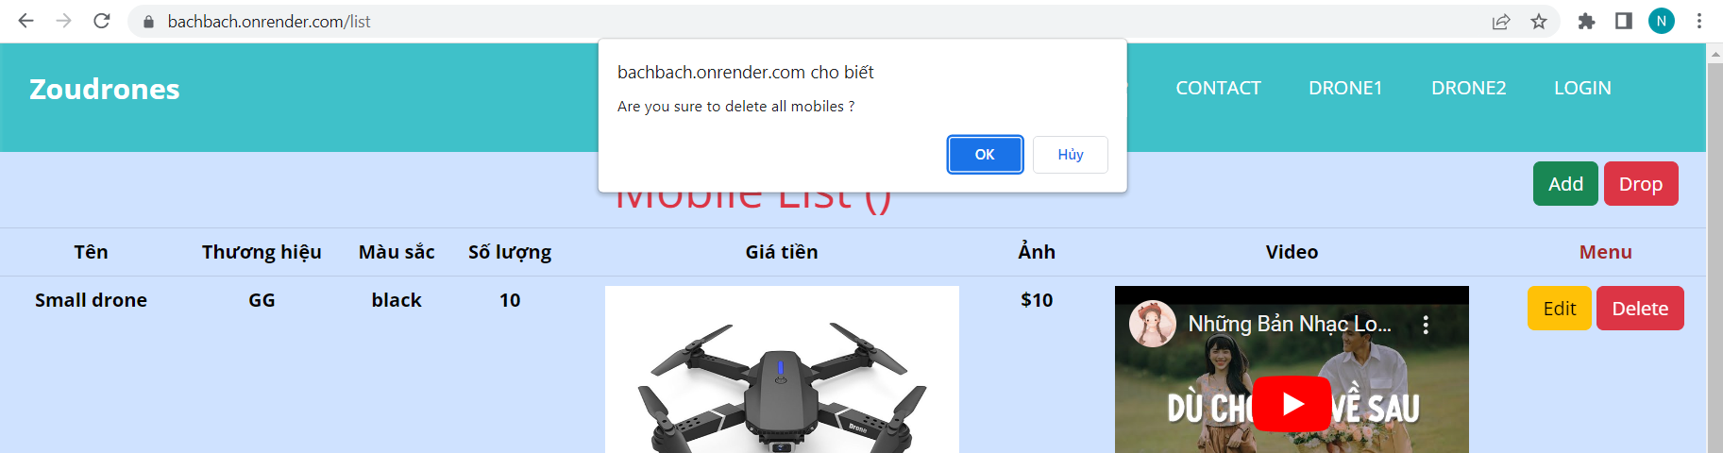

Figure 11: Confirm.

* This view will appear when the “Drop” button is pressed in order to confirm the action.

## Code implement and deploy process:

### IDE:

* Visual code studio is used be cause:
* Cross-platform compatibility: Visual Studio Code works on all major operating systems like Windows, macOS, and Linux, so you can use it on any computer.
* Extensibility: Visual Studio Code has a huge library of extensions that you can add to enhance functionality and customize the perfect development environment for your needs.
* Integrated Git: Git is the most popular version control system in use today. Visual Studio Code has built-in support for Git, making it easy to manage code changes and collaborate with others.
* Intelligent code editing: Visual Studio Code has powerful code editing capabilities, including intelligent code completion, code highlighting, and error detection, which makes it easier to write code with fewer errors.
* Debugging support: Visual Studio Code makes it easy to debug your code with built-in support for debugging scripts and applications.

(visualstudio, 2022)

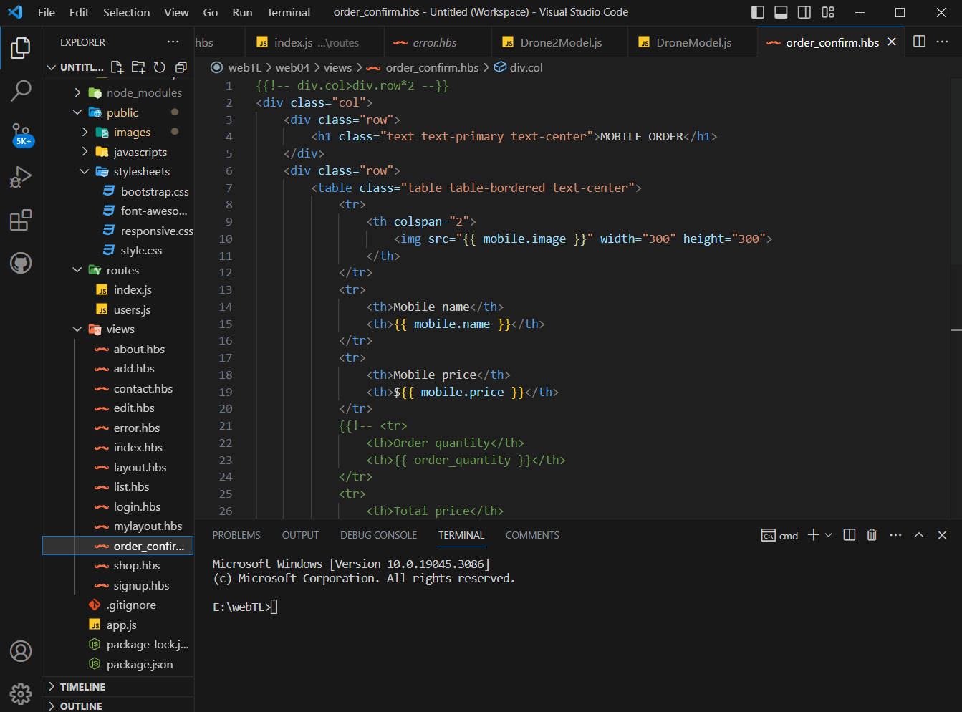

Figure 12: Visual studio code.

### Framework:

* In order to build the web application, I will use ExpressJS framework.
* ExpressJS is a popular web application framework for Node.js that offers multiple benefits to developers. Here are some of the reasons why you should use ExpressJS:
* Scalability: ExpressJS offers a highly scalable infrastructure that makes it easier to grow your web application as your business grows. According to an article on upGrad's blog, "Express.js modules are designed to work together, so it’s easy to add functionality as you need it."
* Easy to learn and use: ExpressJS offers an intuitive and user-friendly interface that makes it easy for even novice developers to learn and use. According to another article on upGrad's blog, "The framework is easy to learn and understand, which makes it approachable for beginner developers and proves to be a great platform for experienced developers."
* Flexibility: ExpressJS provides complete flexibility to the developers to customize the framework as per their needs. You can use any templating engine to create your frontend and use any database (MySQL, MongoDB, Oracle) to handle your data.
* Middleware support: ExpressJS supports middleware, which are functions that can be used to execute additional logic before or after request is processed. Middleware can help you add authentication, logging, error handling, and other custom functionality to your web application.
* Large ecosystem: ExpressJS has a strong community and a vast ecosystem of plugins, modules, and tools that can make the development process faster and easier.

(expressjs, 2022)

### Source code manager:

* I will use github in this project because it help me manage, store and share code with other member of the team.

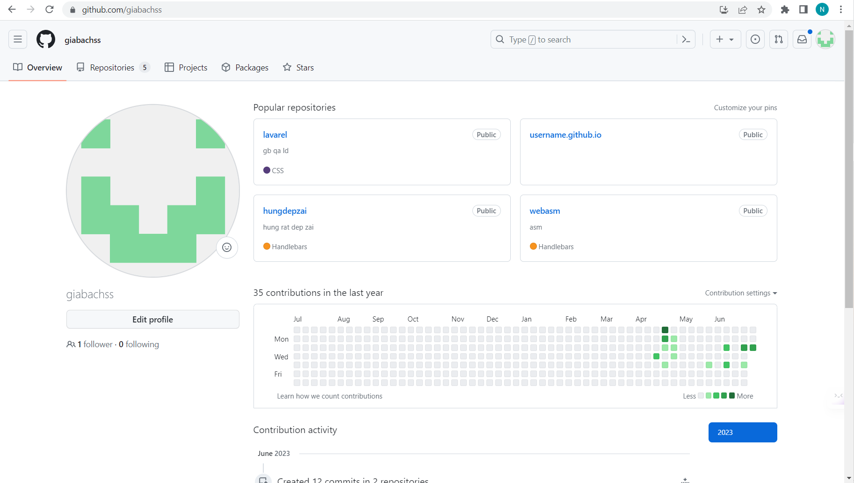

Figure 13: Github.

### Data base server:

* I choose to use MongoDB because of its unique features and capabilities compared to traditional relational databases:
* Flexible and scalable data modeling: MongoDB is a document-oriented database, which allows for flexible and dynamic data modeling. According to a blog post on the MongoDB official website, "With a flexible schema, you can add new fields or delete old ones on-the-fly without impacting existing data."
* Higher performance and scalability: MongoDB is designed to be highly scalable and high-performing, making it an ideal choice for handling large amounts of data. MongoDB can handle high write and read loads, and can scale horizontally by adding more replica sets to the cluster, allowing for greater scalability and performance over time.
* Better developer productivity: MongoDB has a developer-friendly interface and a modern query language that makes it easy to work with. The document data structure also makes it easier for developers to integrate MongoDB with different programming languages and frameworks. According to a blog post on The New Stack, "MongoDB reduces the development time as it gives unparalleled support for developers of all levels."
* Cost-effective: MongoDB's unique features can be a cost-saving decision for businesses, as it eliminates the need for expensive hardware and complex database administration. According to the same blog post on The New Stack, "Not only MongoDB is faster than relational databases, but it is also more cost-effective."

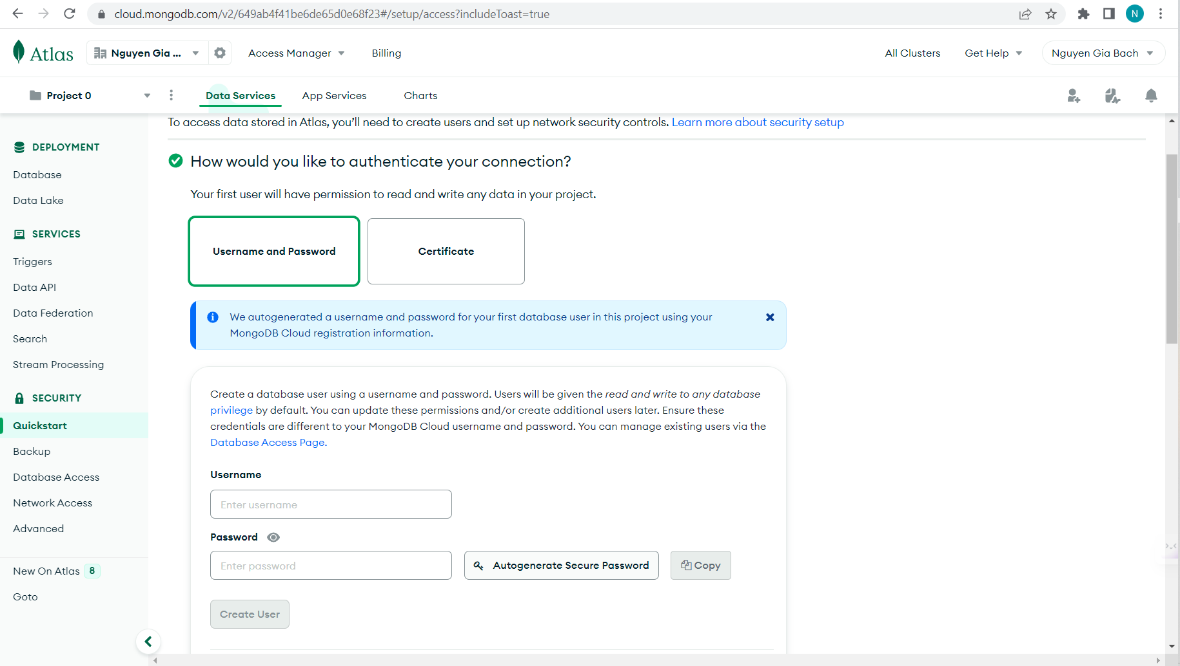

Figure 14: Atlas.

### Cloud computing module:

* I will use Render to deploy the web application to in internet because Render is free to use and support IaaS model.

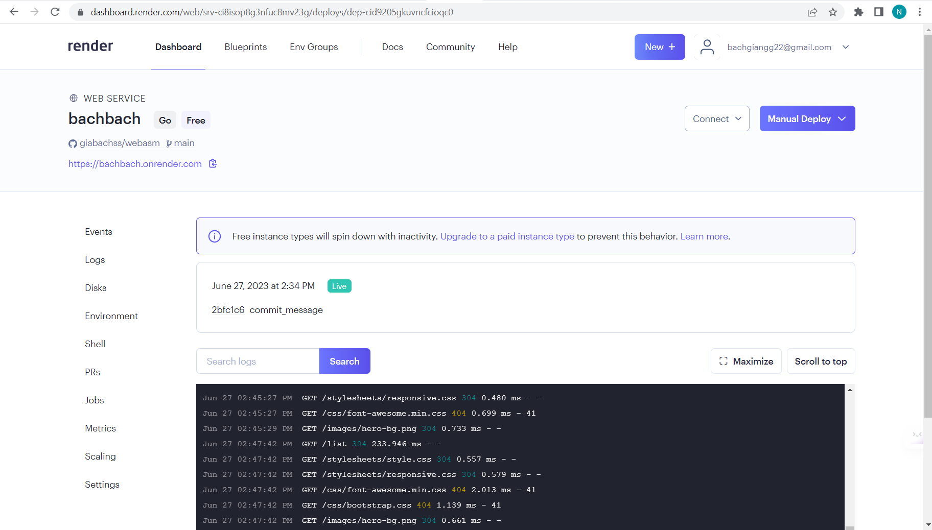

Figure 15: Render.

### Config framework Express on the env:

* In order to use ExpressJS, we need to install nodeJS:

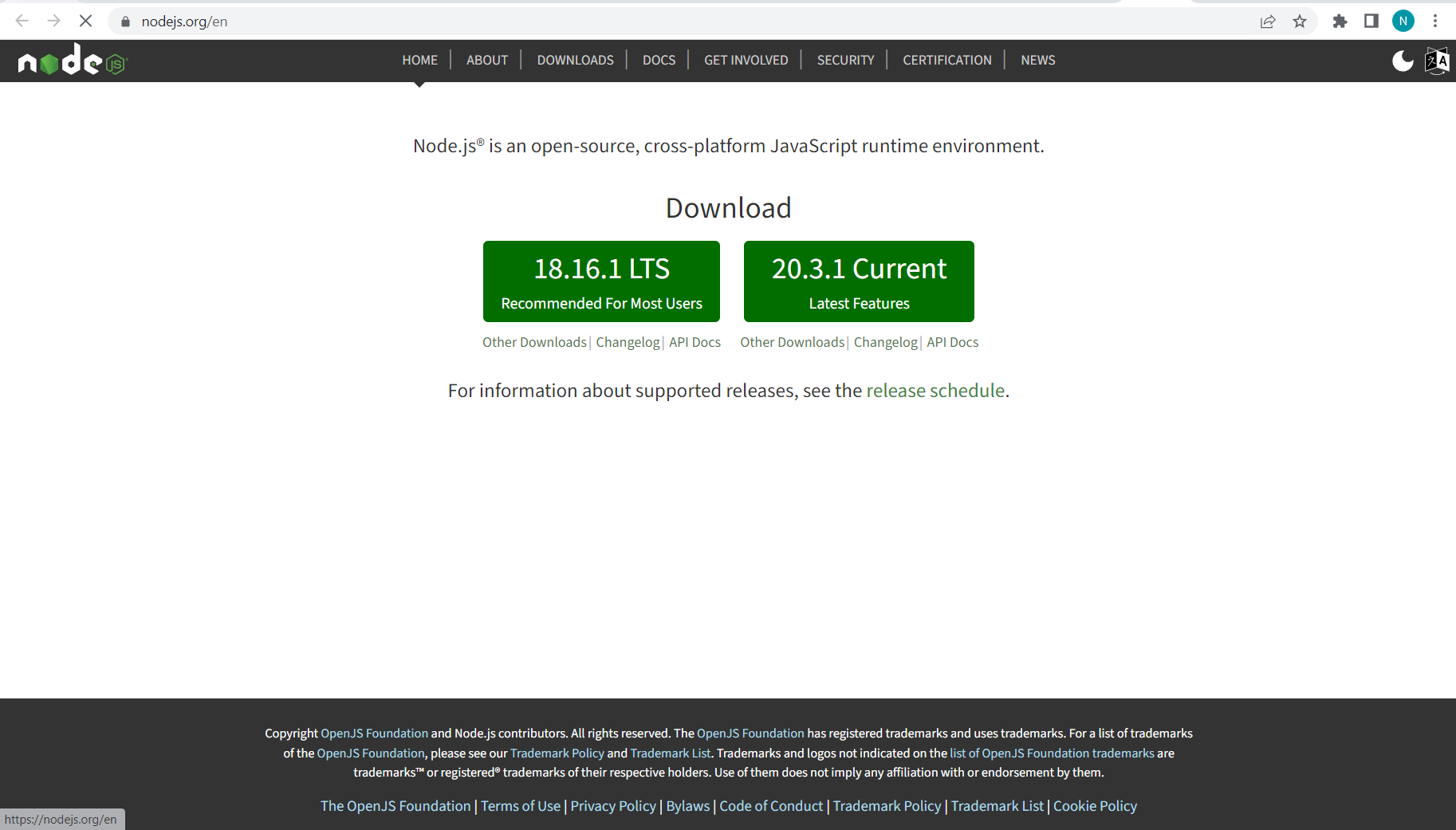

Figure 16: Dowload nodeJS.

* After that we need to create project and user terminal command to install Express with Node pakage manger and other required configuration (using view engine hbs): npm install express

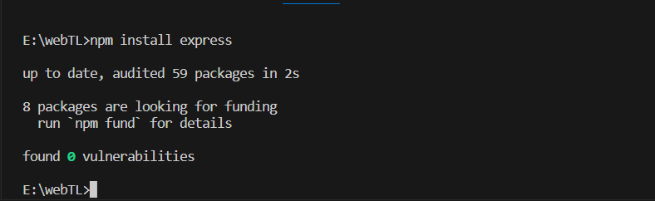

Figure 17: Express install.

### Config and connect with mongodb:

* Create database (Click ”Build a Database”):

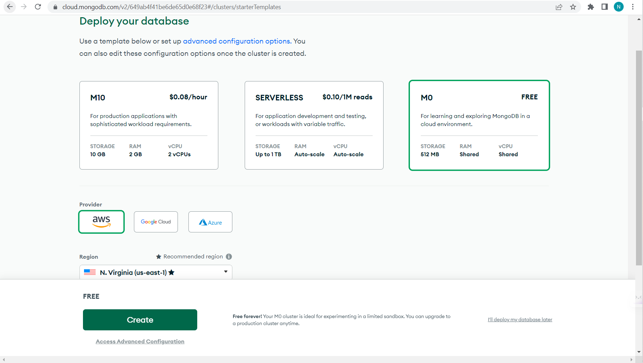

Figure 18: Create database.

* Create user:

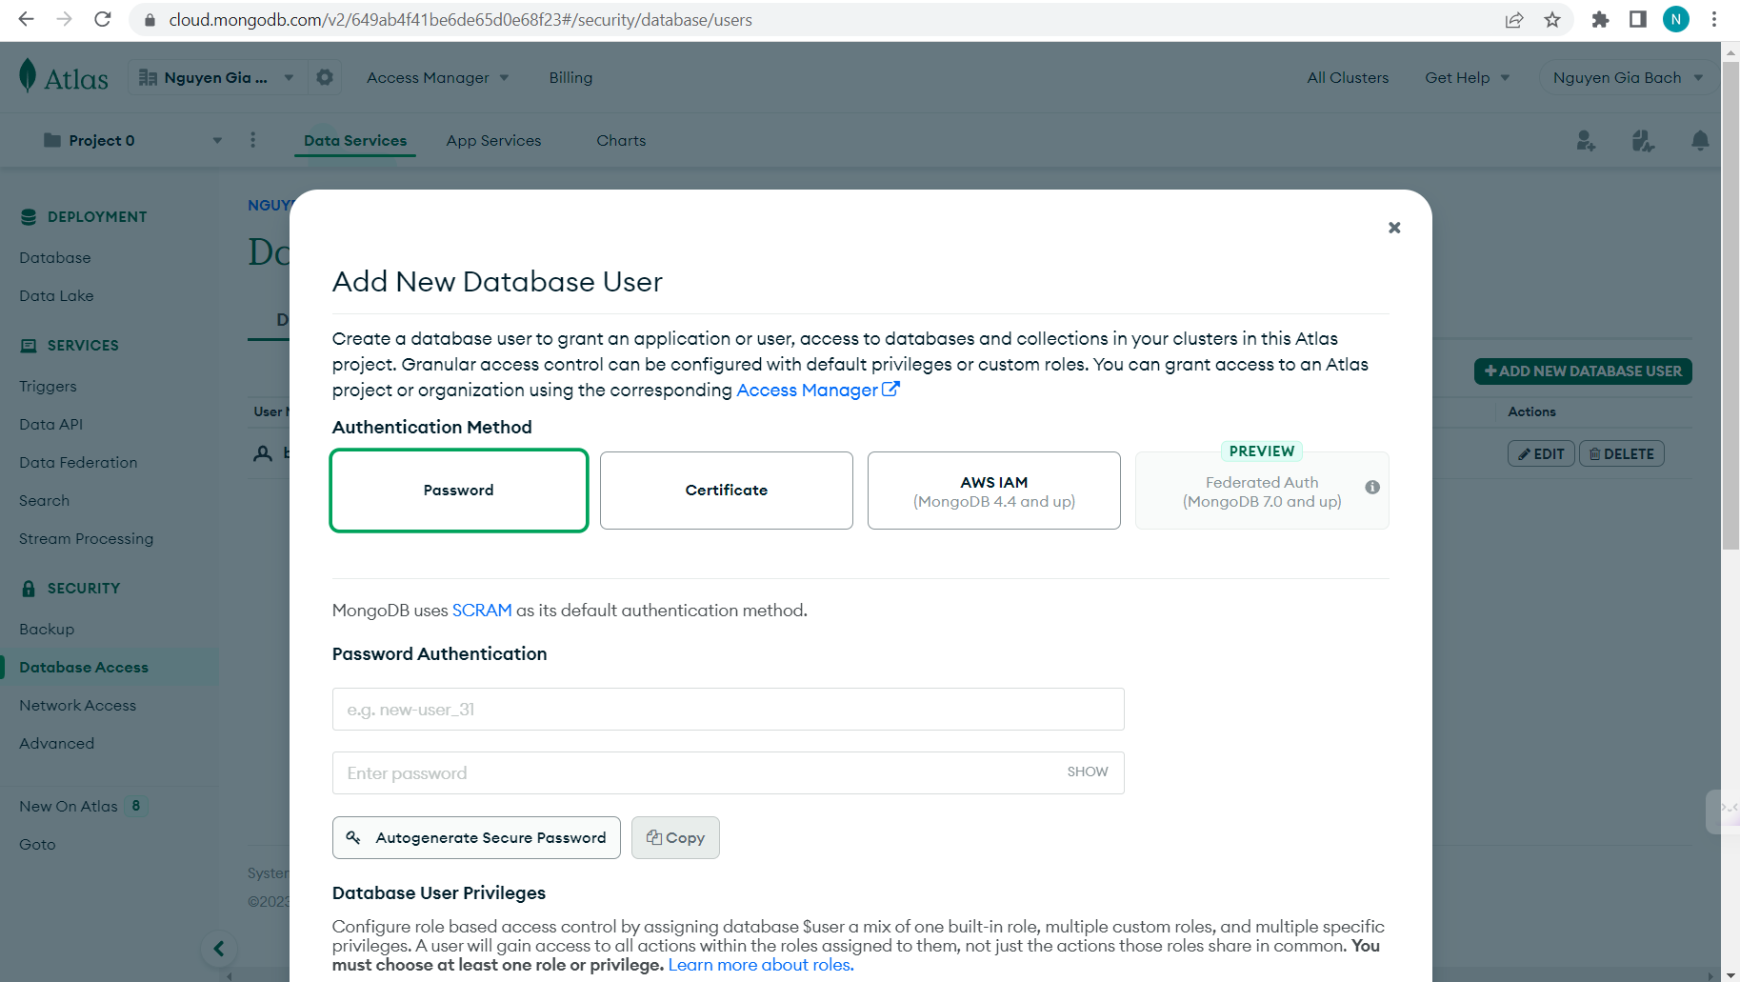

Figure 19: Create user.

* Add connect IP access:

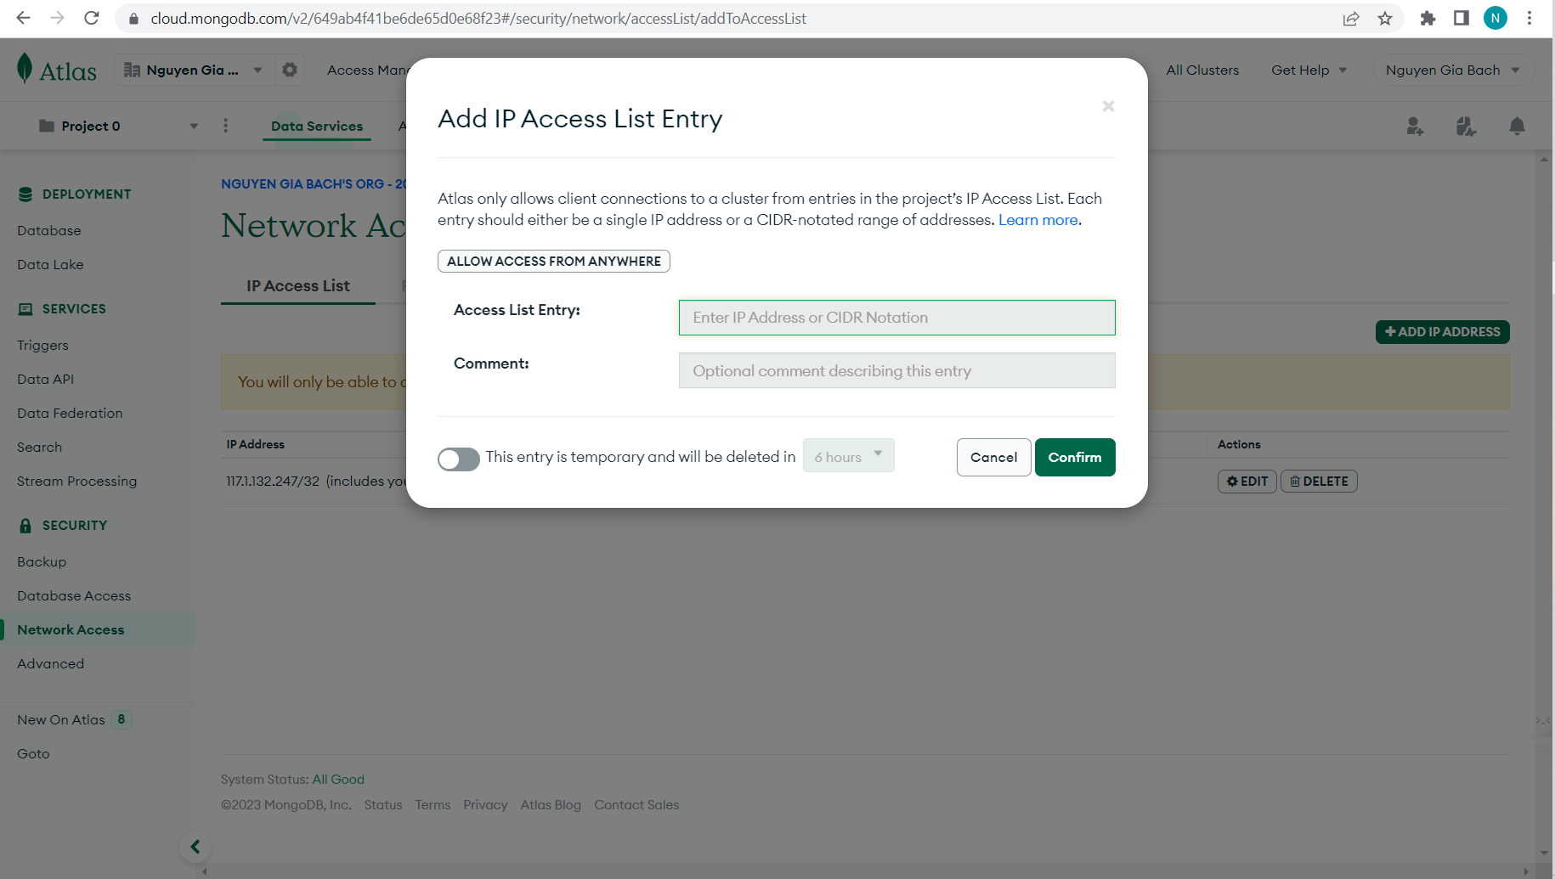

Figure 20: IP address.

* Connect to cluster():

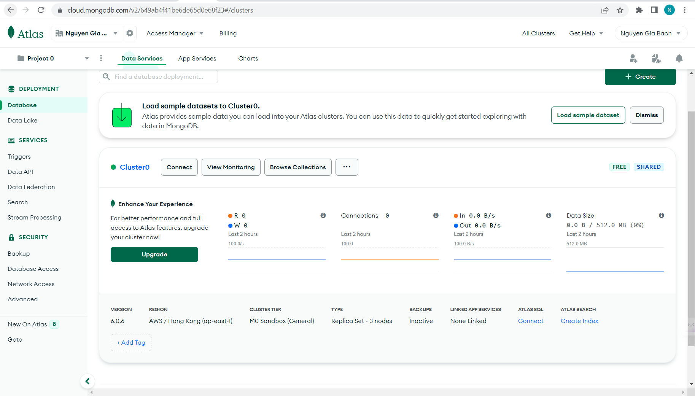

* Choose “Connect”.

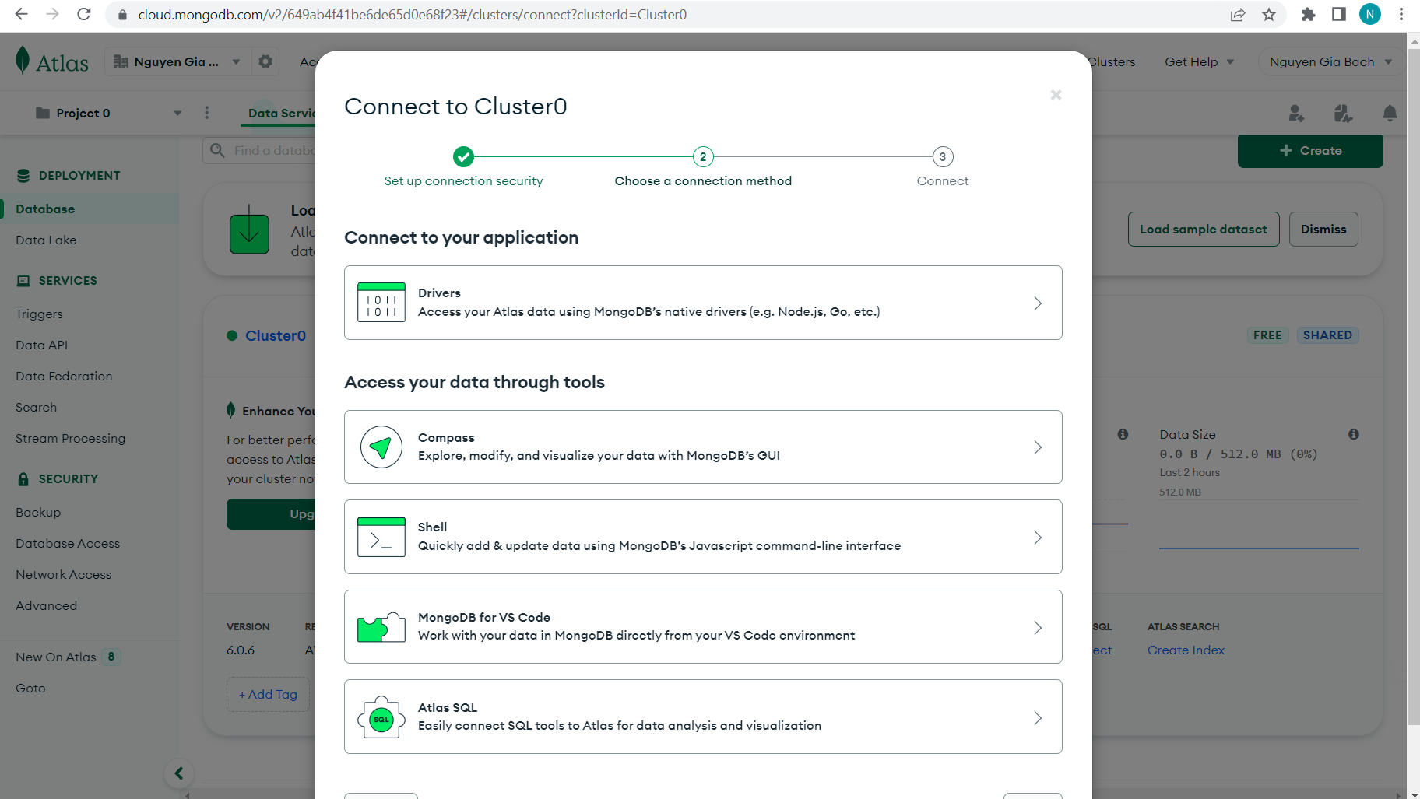

* Choose “Compass” because we are going to use MongoCompass.

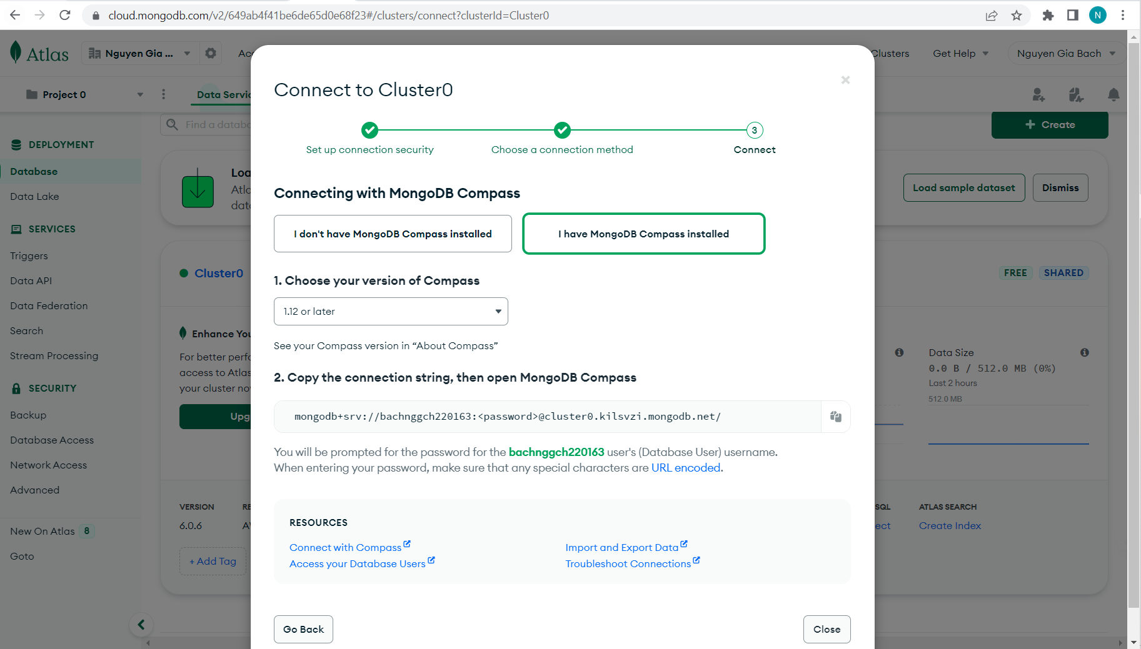

Figure 21: Connection string.

* Choose “I have MongoDB Compass installed” then copy the connection string.
* Open MongoDB Compass and add new connection (paste the connect string with the user password):

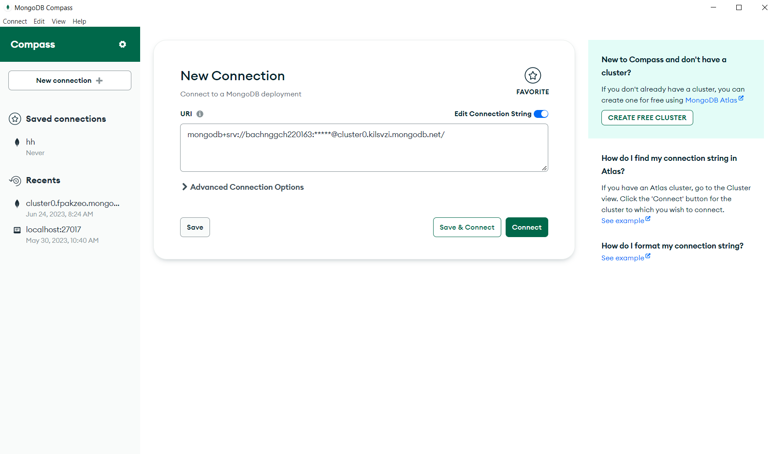

Figure 22: MongoDB Compass.

* You can create new organization here:

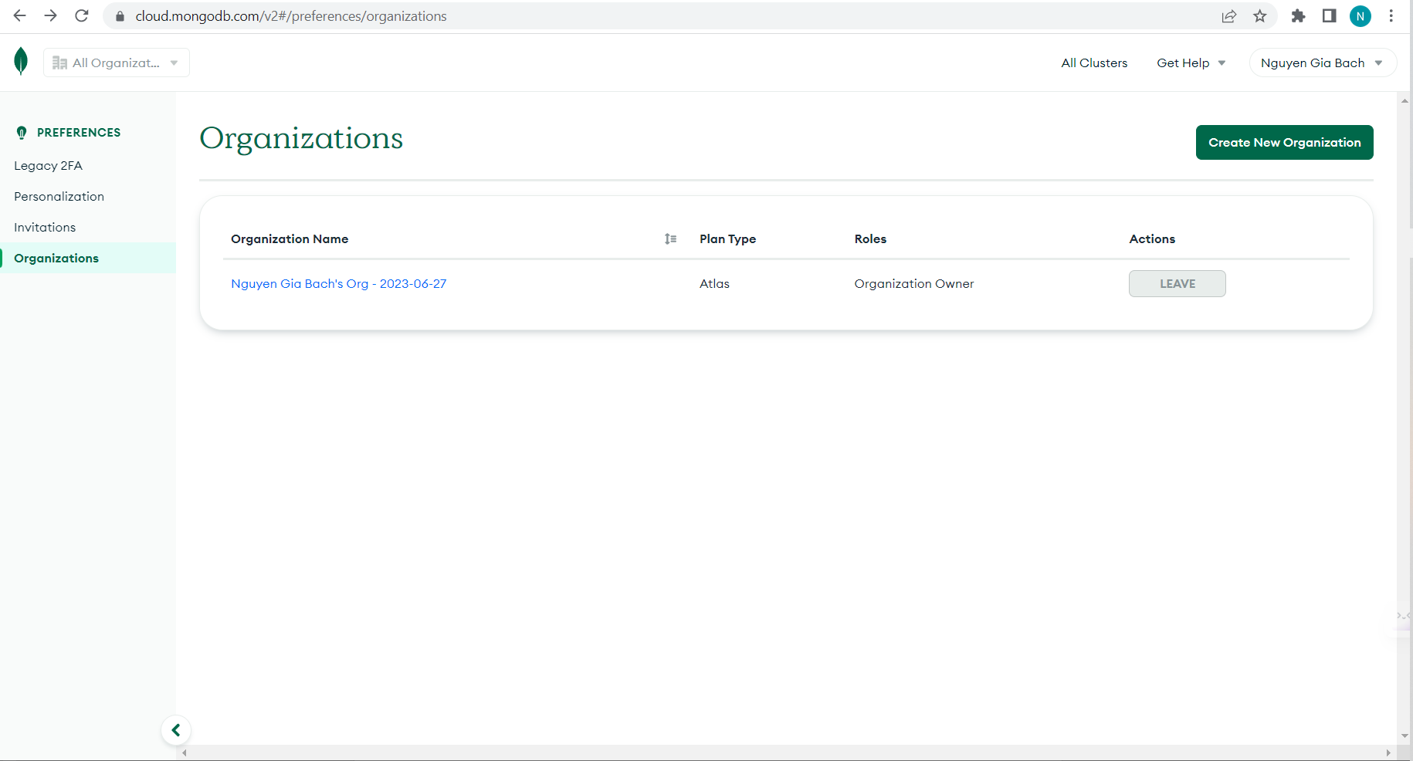

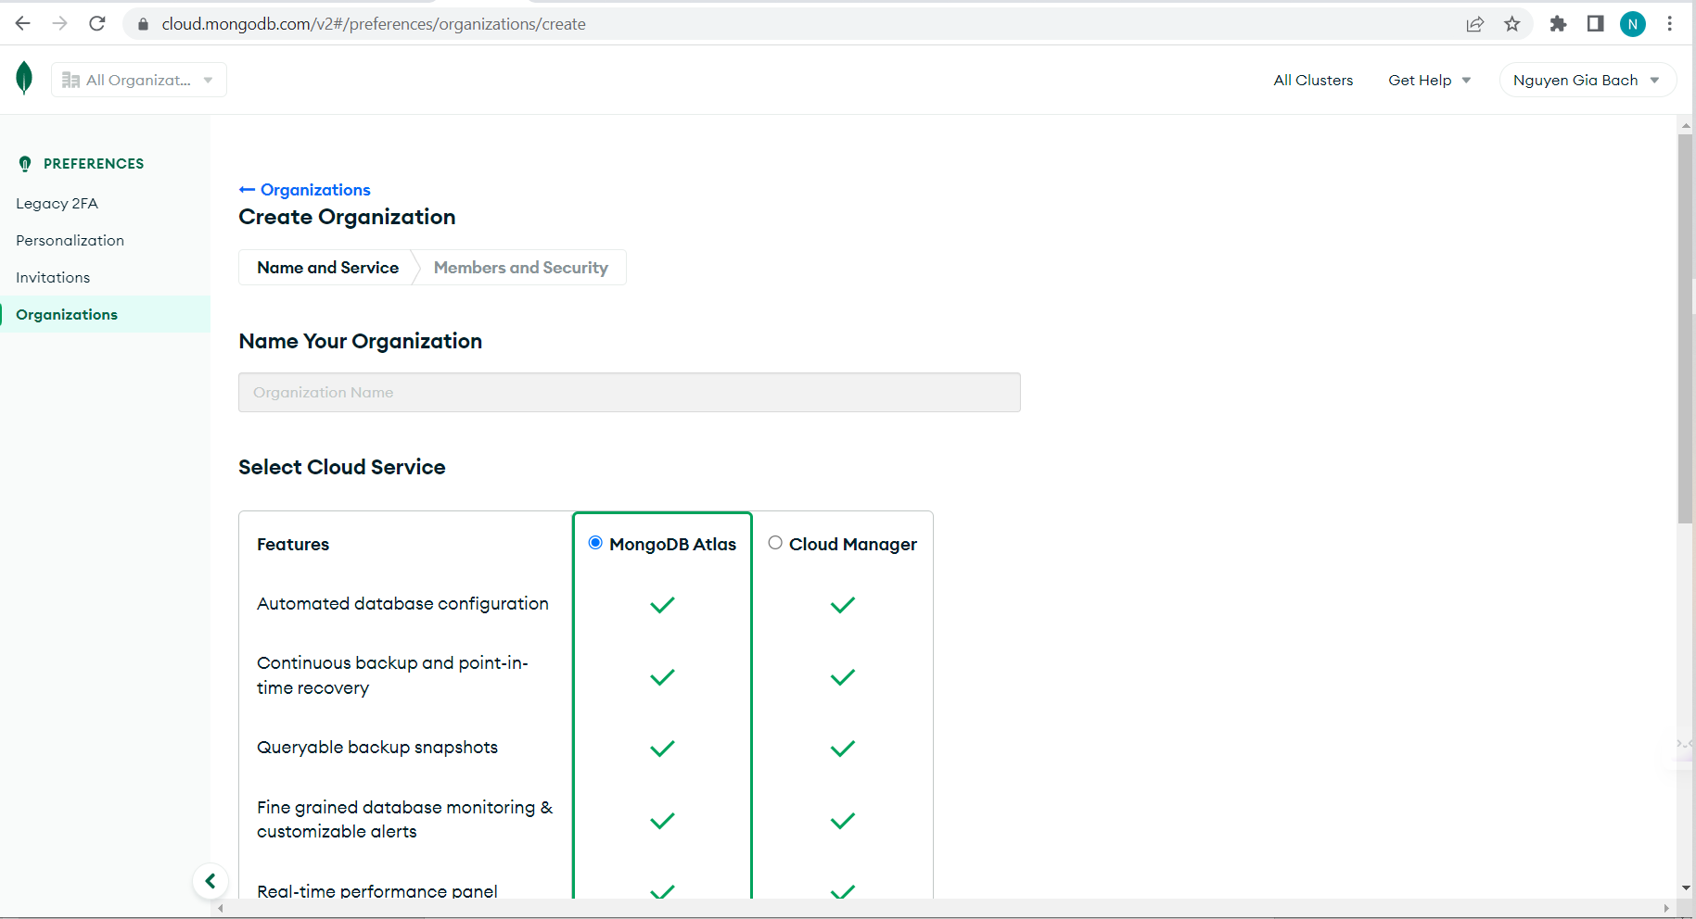

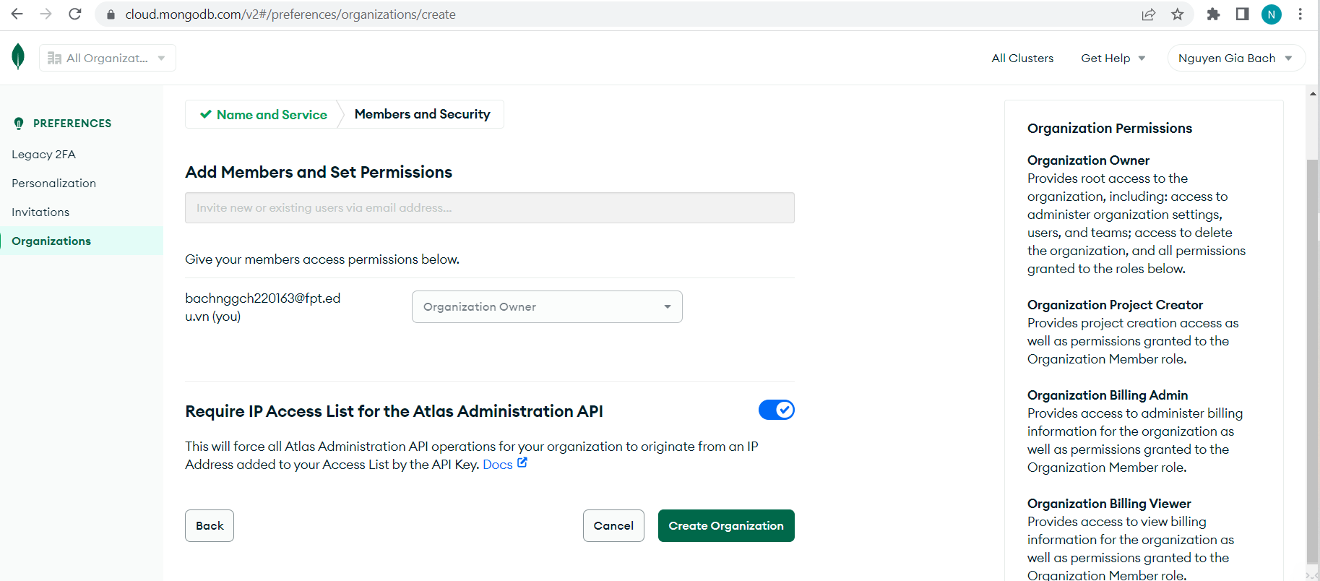

* Success:

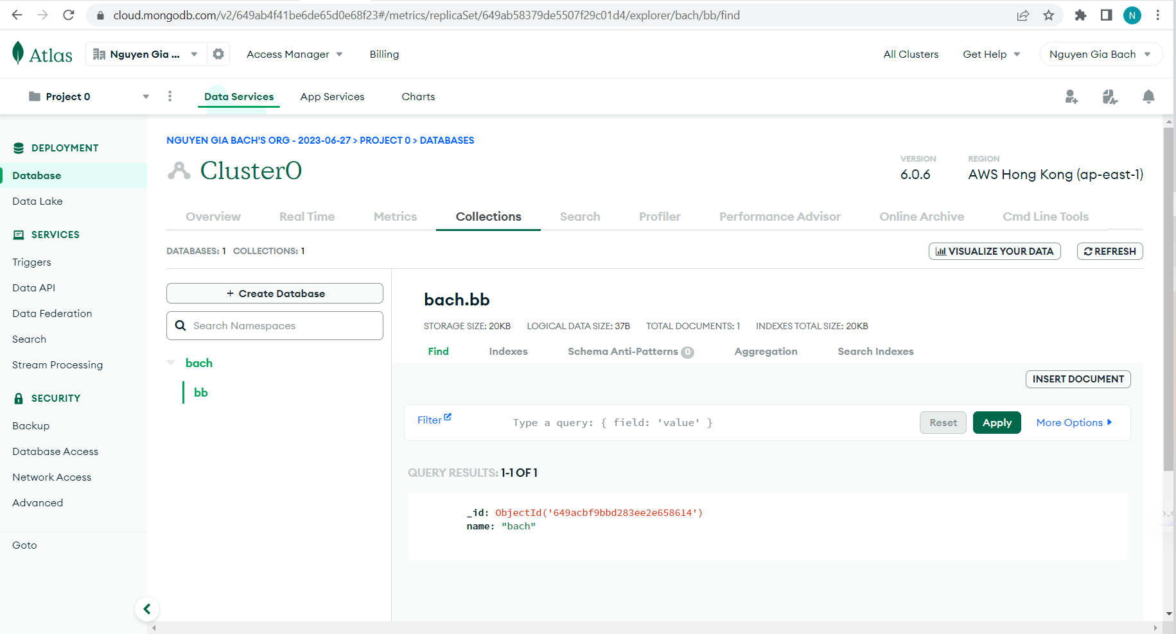

Figure 23: Success.

### Config git and upload files to github:

* I will use github to manage source and deploy it to Render.
* Create new repository:

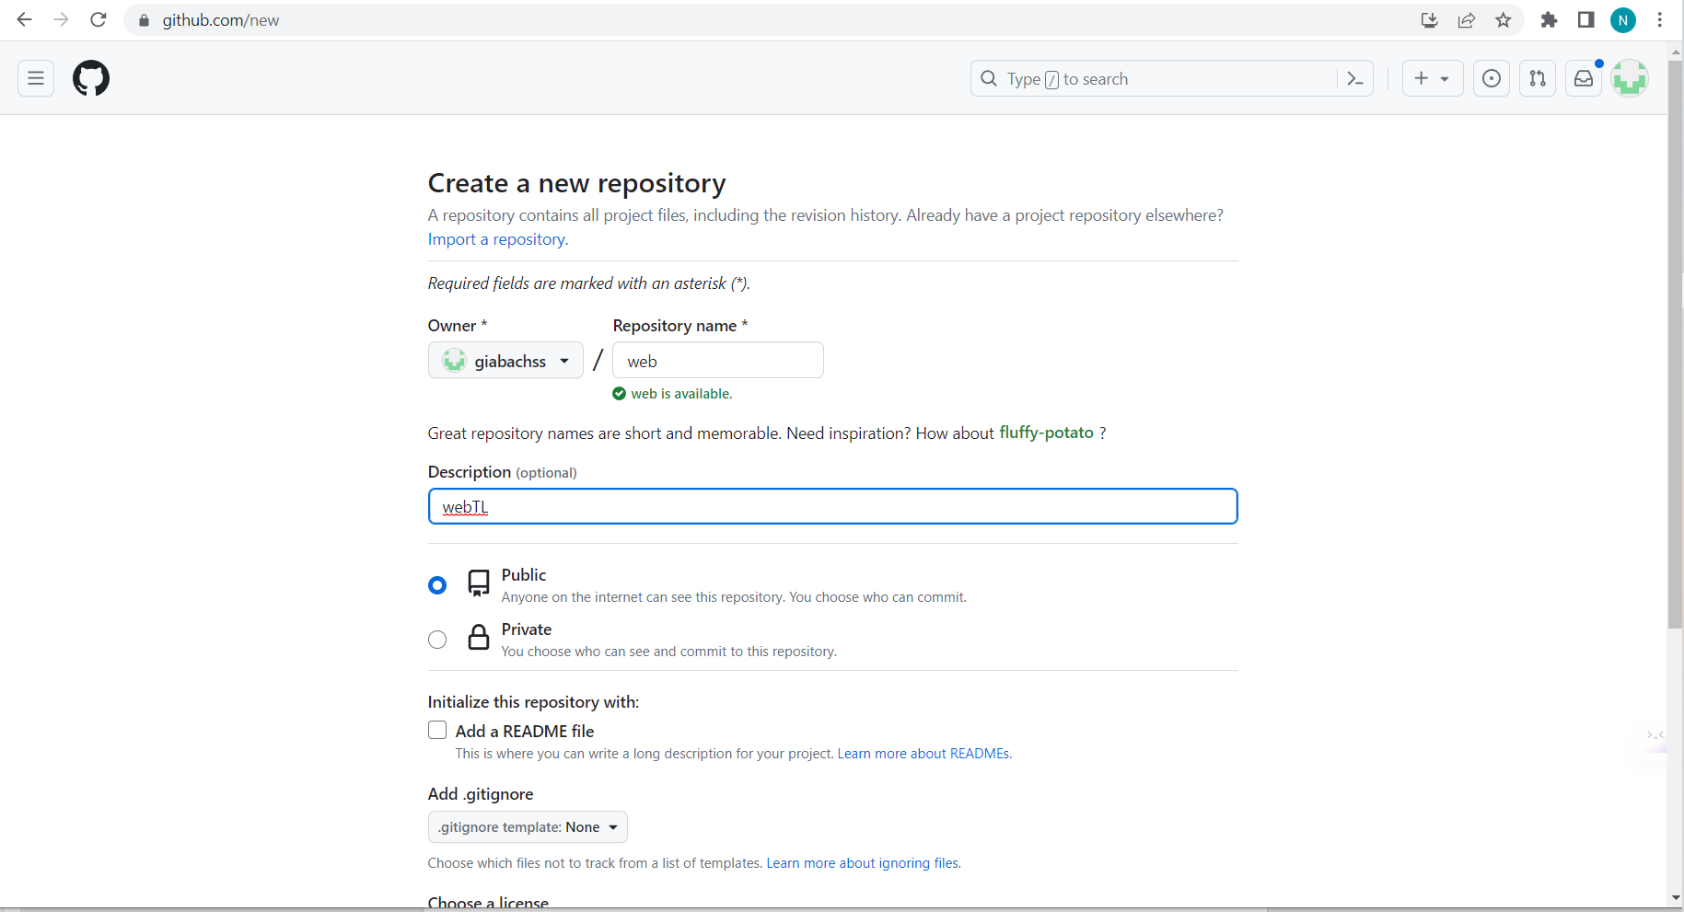

Figure 24: New repository.